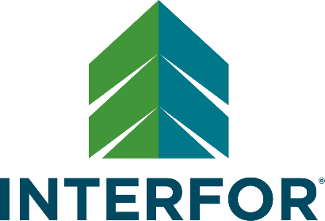

Dal Shemko Memorial Scholarship and
Tolleson-Wood Family Scholarship

Dal Shemko Memorial Scholarship

As Interfor’s first Safety Coordinator, Dal Shemko raised awareness about the importance of employee safety at work. Tragically, Shemko passed away due to a work-related accident. He is remembered by his wife, three children, family and friends. In honor of his life and legacy, Interfor dedicates this scholarship to Dal Shemko. At Interfor, making sure our people head home safe at the end of the day is our top priority. This scholarship is open to children of Interfor employees in our Canadian and US West regions.

Tolleson-Wood Family Scholarship

The Tolleson Lumber company was a highly respected family-run business that started in the US South in 1919. As the President, Rusty Wood was an honest, hard-working, and dedicated leader. He brought in a data management system that was ahead of its time in Georgia, and he would re-invest in the mills to improve their efficiency. Interfor acquired Tolleson Lumber in 2014, and Wood’s commitment to excellence and the well-being of his employees rings true to Interfor’s core values. This scholarship is open to children of Interfor employees in our US South region.
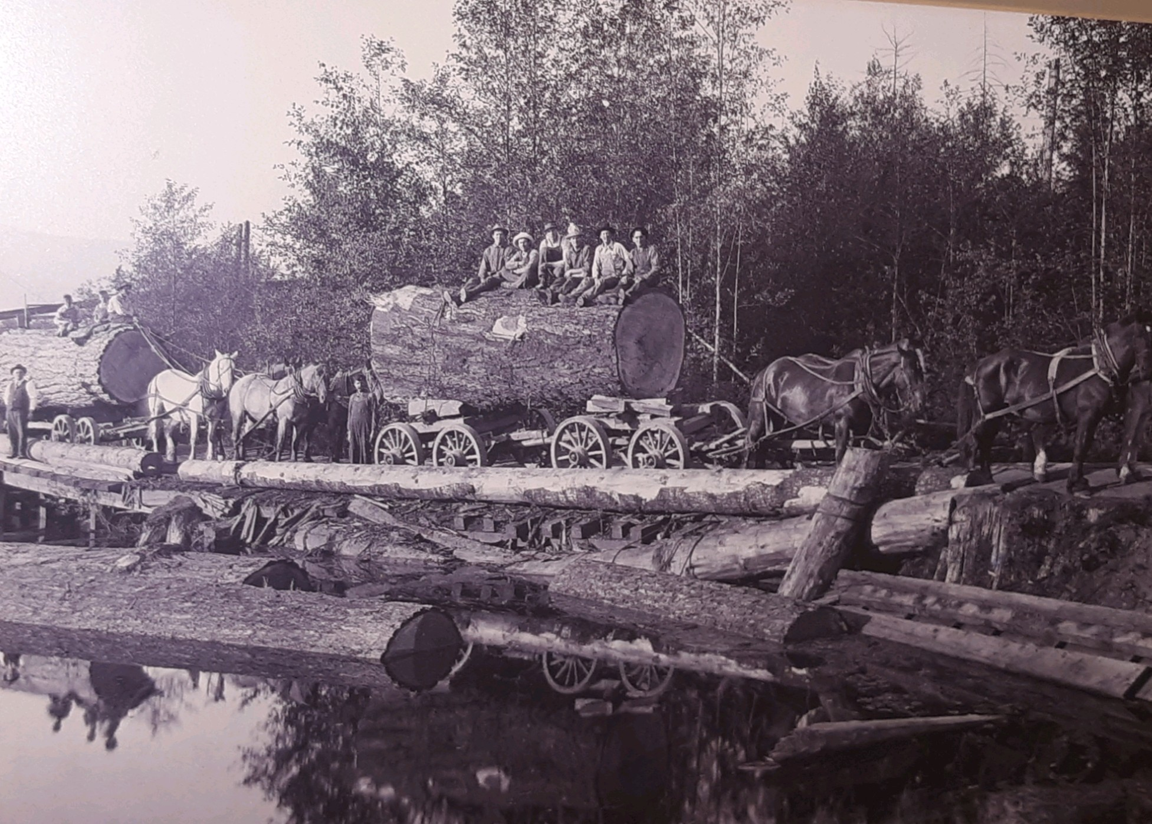

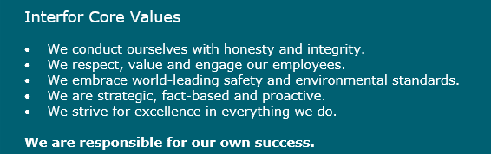

Dal Shemko Memorial Scholarship and
Tolleson-Wood Family Scholarship

Application Deadline May 21, 2021

Name of applicant | Name and division of applicant’s  parent/guardian employed at Interfor
Home mailing address (This is where the check will be mailed if you are successful.)
Phone number | Email
Name of school currently enrolled | Address
Institution to be attended & start date | Address

Requirements for eligibility:

- Applicant’s parent/guardian is an Interfor employee.
- Applicant will be pursuing full-time post-secondary education or technical/trades training in autumn 2021.*
- Applicant must be younger than 25 years of age.
- A letter of recommendation from a teacher, coach, or employer.
- A personal letter of recommendation from an individual of the applicant’s choice.
- A copy of applicant’s most current school/post-secondary transcript highlighting academic standing.

*Please note that if you receive an award, you will be required to provide proof of enrollment to start in autumn 2021. If you decide to defer your education (up to six months), the scholarship will be put on hold until proof of registration is provided. If you defer more than six months, your scholarship is forfeit.

We’re excited to learn more about you! In a video or photo, tell us about how your teachers or peers would describe you, and describe what inspires you to stay motivated and do your best. (Note: maximum video length is 60 seconds. You can send the as an attachment with your application or include a link to your video below)

What are your future career goals and what do you hope to accomplish?

Tell us about a time where you experienced adversity or challenges and how you overcame it.

Describe a meaningful experience where you gave back to the community.

Describe one thing you've learned about yourself as a leader or team member. What advice would you give to your past self?

How will receiving a scholarship make a difference in your life?

Have you attached the required letters of recommendation? ___YES ___NO

Have you attached the copy of the required transcript of marks from your last school term? ___YES ___NO

Have you received an Interfor scholarship before? ___YES ___NO

If so, what year? _____

Completed application forms must be received by May 21, 2021 via e-mail to communications@interfor.com or regular mail to:

Interfor Scholarships
Attn: Communications
1600-4720 Kingsway
Metrotower II
Burnaby, BC V5H 4N2
Canada

